Supporting Assessment in Science
The pack contains material that can be used to support your teacher assessment in science. It is linked to the present QCA units of work and the Levels are taken from the KS2 Programme of Study level descriptors and the QCA’s Assessing Progress in Science.

What’s included
1.Assessing Knowledge and Understanding.
What are the level descriptors for this unit of work, and what can it mean for your pupils and your planning?
Unit of work
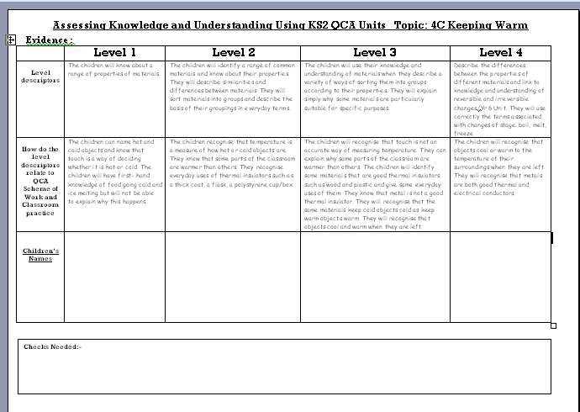
Level descriptor from the Programme of Study and Assessing Progress in Science
How this relates to what the pupils will do and say you may wish to adapt these for your own activities
A record of pupils assessed at this level
Space to add the names of pupil’s you may need to question
Being confident as teachers of the level descriptors for each level, and in particular what this means in relation to a particular activity and pupil explanation gives us the opportunity to, not only assess the pupils progress but be aware of the next step. These descriptors are provided and below this are examples of what this could actually mean to the pupils in this unit o work.
There is also the opportunity to record individual pupil’s progress against their expected levels, and finally identify any pupils where clarification of their understanding may be needed.

2.Assessing Scientific Enquiry
The scientific Enquiry Sheets have been produced for each of the 4 Strands, and we have provided two examples per Key Stage. The particular details need to relate to individual enquiries in your scheme of work and the particular focus.

3. Supporting pupils Self, and Peer Assessment in Science
The materials for ‘Aiming High in Science’ are also linked to the QCA units in KS1 and 2
It includes ‘I CAN’ statements in pupil speak for both the knowledge and understanding in these units of work and the 4 strands of Scientific Enquiry. Both pictures and levels have been identified to give pupils an idea of what is expected from them. We have used an Aiming Higher theme, with balloons, planes, rockets and space stations, but these of course can be changed if you wish, as can the use of levels. At the top of each page there is a box for the pupil’s name and for their targeted ‘level’ or picture. We have also provided stickers to use with the pupils.
The Aiming High in Science also includes a copy of display material which will give a visual
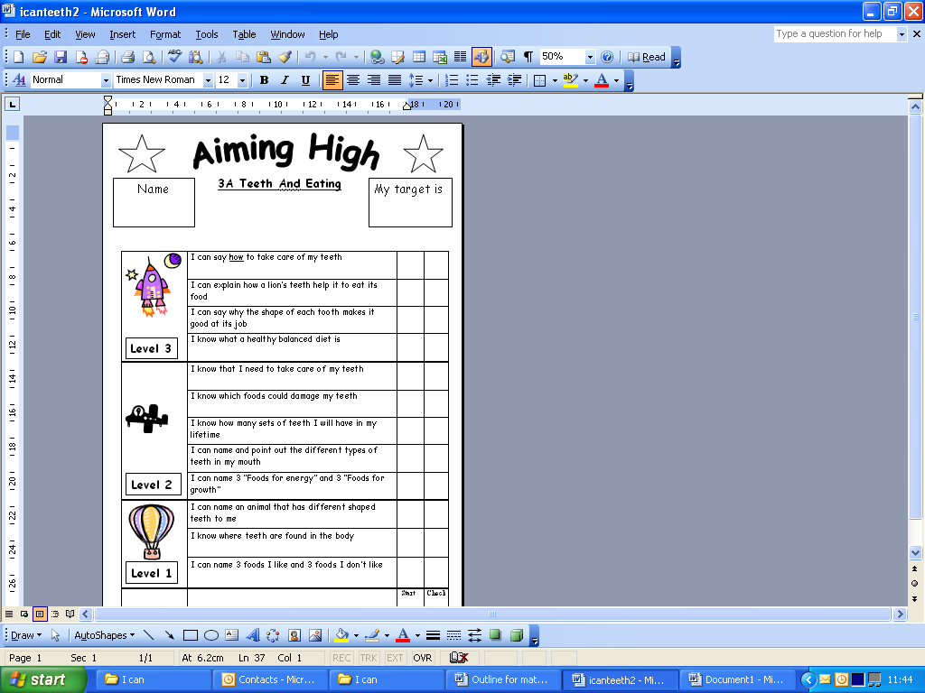
reference for the pupils.
The ‘I CAN’ pupil material can be
printed in a booklet format
for each pupil, or, as
individual sheets for a file.

We hope you will find the
material useful.

I would like to thank the
following teachers for their
input in producing the
material primarily
Michelle Waters – Lead Teacher for Primary Science
Bedlington West End First School
and
Claire Phillips Bedlington West End First School
Nicola Foy Longhoughton First School
Denise Porter Seaton Sluice First School

Kay Sample Primary Science Consultant
Northumberland L.A Contact 01670 533545 ksample@northumberland.gov.uk
Please let me know what you think of the material

